School Of Mechanical & Manufacturing Engineering, NUST

Department of Mechanical Engineering

CS-114 - Fundamental of Programing

Lab Manual # 10

**Course Instructor:** Dr Khwaja Fahad Iqbal

**Lab Instructor:** Muhammad Affan

**Student Name: ZORAIZ ABBAS**

**CMS ID: 454752**

**Date:**

**27 DEC 2023**

**Task 1:**

Iterate Through Vector Using Iterators and print all pushed elements. Next you need to push integer 5 and remove element at that position.

Code:

#include<iostream>

#include<vector>

using namespace std;

int main(){

vector<int>v1;

for(int i=0;i<10;i++){

v1.push_back(i+5);

}

cout<<"The pushed integers are: ";

for(int i=0;i<v1.size();i++){

cout<<v1[i]<<" ";

}

cout<<endl;

v1.push_back(1);

int removingposition=9;

if(removingposition>=0&&removingposition<10){

v1.erase(v1.begin()+removingposition);

}

cout<<"the pushed integers after removing the element at given position are: ";

for(int i=0;i<v1.size();i++){

cout<<v1[i]<<" ";

}

return 0;

}

**Output:**

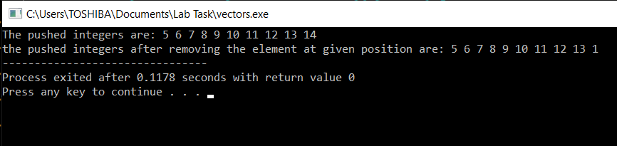

**Task 2:**

Write a complete C++ program that uses 2 vectors, 1 for names (string) and 1 for grades (int)

* 1. Ask the user for the number of name/grade pairs that will be entered.
  2. Display the mean of the grades.
  3. Display the median of the grades.
  4. Display the mode of the grades.
  5. Display the names of the students with the mode as their grade.

**Code:**

#include<iostream>

#include<vector>

#include<string>

using namespace std;

int main(){

int p;

vector <string> name(p);

vector <int> grade(p);

cout<<"enter the number of pairs: ";

cin>>p;

cout<<endl;

for(int i=0;i<p;i++){

cout<<"Enter the name of person "<<i+1<<": ";

cin>>name[i];

cout<<endl;

cout<<"Enter the grade of person "<<i+1<<": ";

cin>>grade[i];

cout<<endl;

}

cout<<endl;

double sum=0,mean;

for(int i=0;i<p;i++){

sum+=grade[i];

}

mean=sum/p;

cout<<"he mean of the grades is: "<<mean;

cout<<endl;

cout<<endl;

if(p%2!=0){

int med=p/2;

cout<<"The median of grades is: "<<grade[med]<<endl;

}

else{

int med1=p/2;

int med2=(p-2)/2;

cout<<"The median of the grades are: "<<grade[med1]<<" and "<<grade[med1]<<endl;

}

int mode,currentCount=1,maxCount=1;

for(int i=0;i<p;i++){

if(grade[i]==grade[i+1]){

currentCount++;

}

else{

if(currentCount==1){

cout<<"There is no mode of the grade"<<endl;

break;

}

}

if(currentCount>maxCount){

maxCount=currentCount;

mode=grade[i];

}

}

if(currentCount!=1){

cout<<"The mode of grades is "<<mode<<endl;

}

cout<<"The names of the students with mode as their grade are: "<<endl;

for(int i=0;i<p;i++){

if(grade[i]==mode){

cout<<name[i]<<" has grade: "<<mode<<endl;

} }

return 0;

}

**Output**:

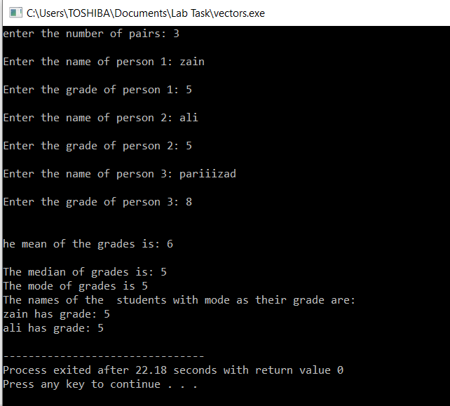

**The end**